Introduction

Name：ZL-9027B Electronic Bottle Cap Torque Tester (with built in printer)
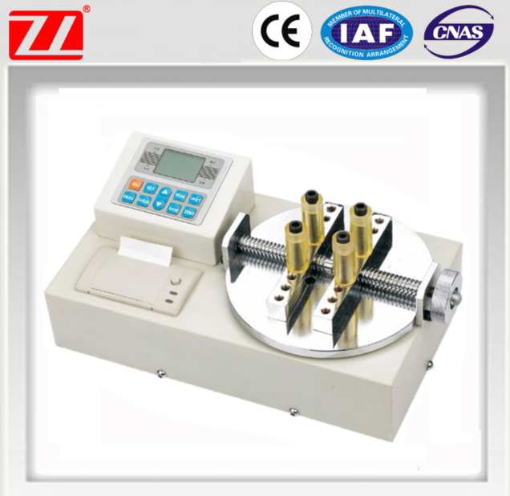

Specifications
Electronic Bottle Cap Torque Tester
1,test range 1~20Nm
2,accuracy +/-0.5%
3,LCD display
4.produce many kinds of tester
5. With built in printer
Instrument Summary:
Bottle cap torque test machine is one of intelligent multi-function instruction equipment for testing or inspecting many kinds of caps with torque. It specially is used on testing the torque of cap or lamb cap. It is widely used on product control system, with the function of easy to operate, high accuracy and economy.
Technologic Specification:
Type | With printer |  |  |  |  |  | 2202-20
Index | No printer | 2202-N1 | 2202-N2 | 2202-N3 | 2202-N5 | 2202-N10 | 2202-N20
Measuring range / Division value | N·m | 1.0000/0.0001 | 2.0000/0.0001 | 3.0000/0.0001 | 5.0000/0.0001 | 10.000/0.001 | 20.000/0.001
Measuring range / Division value | Kg·cm | 10.200/0.001 | 20.400/0.001 | 30.600/0.001 | 51.000/0.001 | 102.00/0.01 | 204.00/0.01
Measuring range / Division value | Ib·in | 8.850/ | 17.700/0.001 | 26.550/0.001 | 44.250/0.001 | 88.50/0.01 | 177.00/0.01
Precision |  | ±0.5%
Peak Value Sampling Frequency |  | 2000 HZ
Power |  | 8.4V 1.2VX7 Ni-MH Battery group
Charging Time |  | 4~6 Hours
Continuous using time of battery |  | About 10 Hours
Battery life |  | ≥300 times
Size |  | 400mm×200mm×200mm
Net Weight |  | 12KG
Power adapter |  | Input:AC 220V 50HZ Output:DC 10V 300mA

